***Tips for Maintaining the dashboard***

Video Walkthrough (please copy paste link into your browser): <https://drive.google.com/drive/folders/1pnqo8PnboSldHle8w13-cltSOJzRU1JS?usp=sharing>

1. Minor changes wrt formatting, layout and placement can be done from within the online PowerBI app itself - the file is available as the most recent one found in "My Workspace"

2. For more detailed bug fixing, it is recommended to download the .pbix file and use PowerBI Desktop to make the changes to the data, sources or relational schema. It can be downloaded for free here: https://powerbi.microsoft.com/en-us/desktop/

3. The file can be downloaded from the online app dashboard by clicking on "File" > "Download the .pbix file"

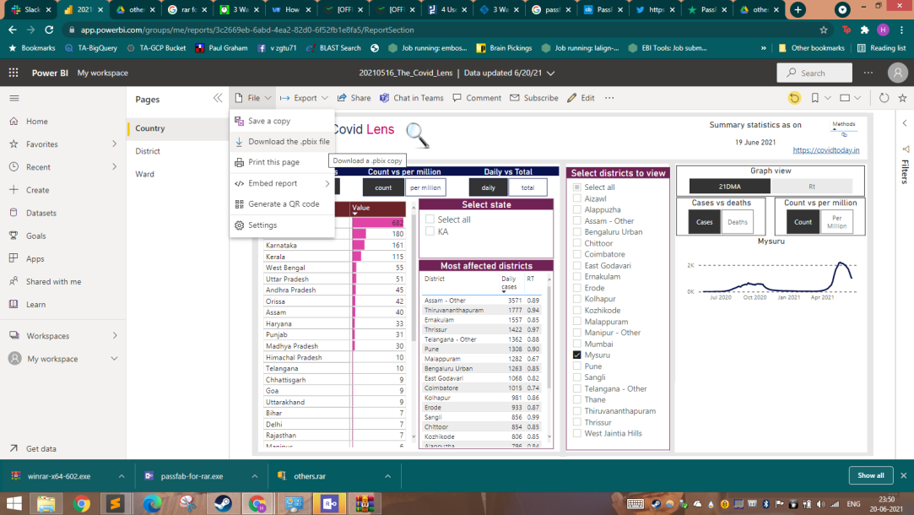

4. After the download is complete, launch the dashboard and you shall see a similar view : 3 tabs on the left allow you to switch between three functional views - Report, Data and Model. In brief, the report view allows us to make visible changes to the dashboard, Data view helps us look at the data and make new columns and tables, while the Model view helps us define the relations between the various tables.

Report View

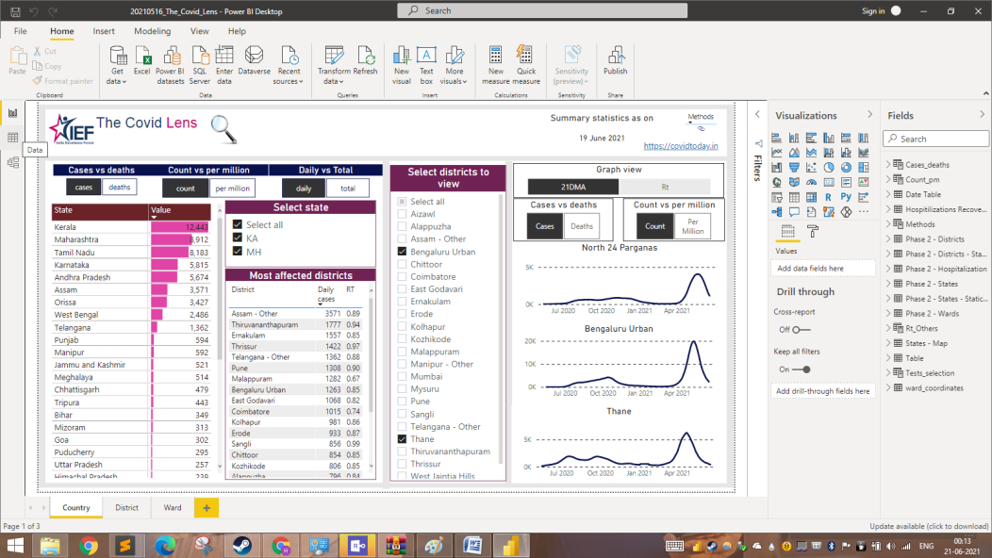

Data View

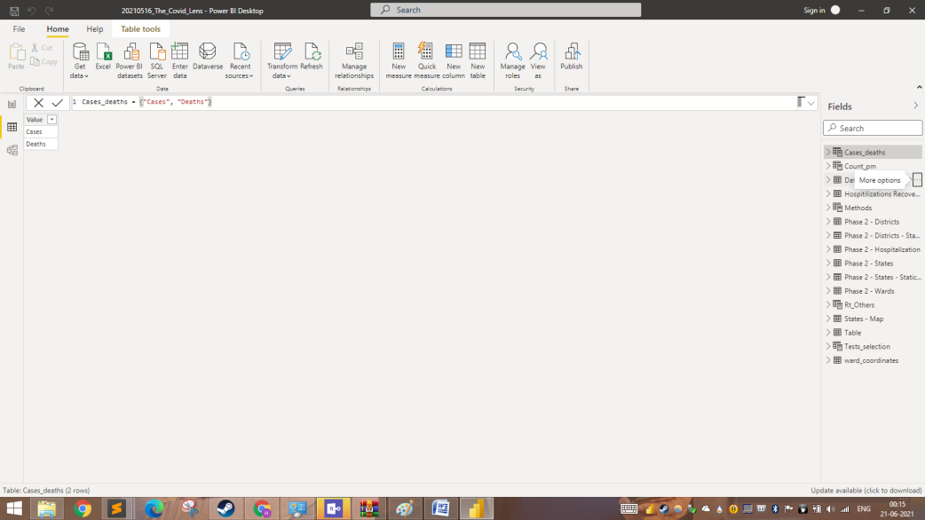

Model View

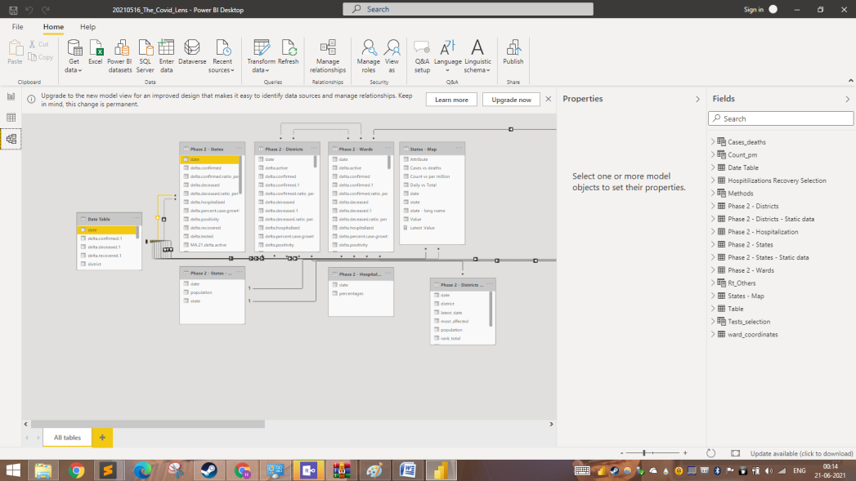

5. To change the data source or check for errors during loading, go to the Data view > Select "more options" next to any table name on the right > Edit Query to open the Power Query Editor.

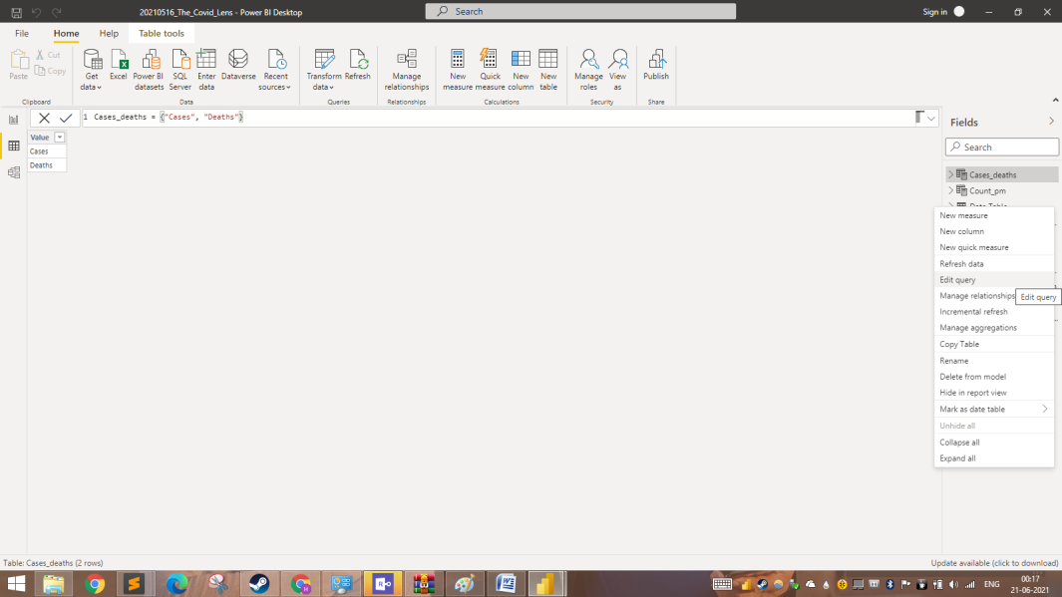

6. The opened window will look similar to the image below, with errors reported on the table of the Queries tab. The other tables can be found under the Other Queries header in the same section.

Changes to the same can be made using the GUI but this can sometimes break the dashboard, hence it is recommended to use the Advanced Editor instead for major changes or changing the data source (provided the format is similar).

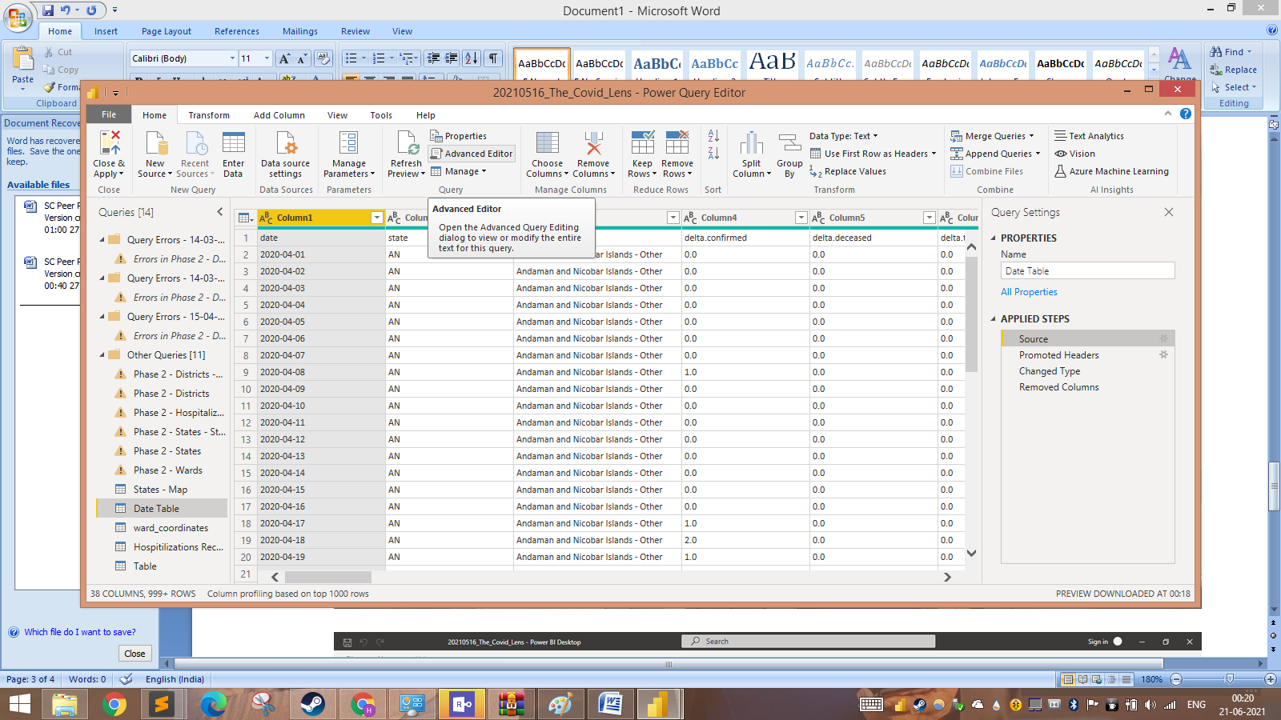

7. As an example, the data source can be changed by changing the highlighted section below to the appropriate Public URL to change the source without majorly breaking the dashboard connections.

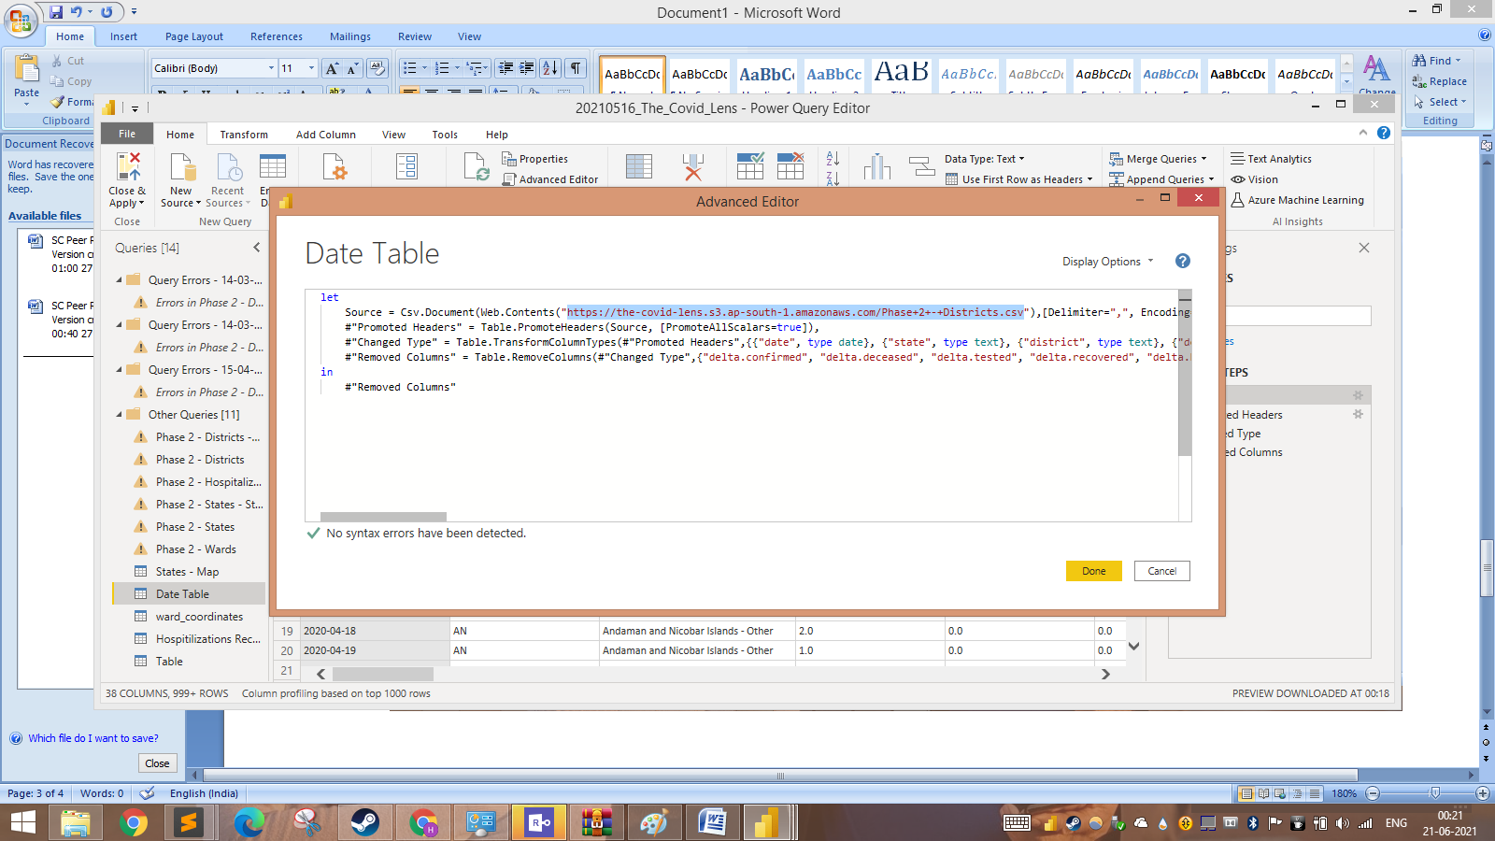

8. Additionally if you come across a similar view as below, select "Connect" after ensuring the directed URL is correct.

